**Bus transport between Pardubice Airport and Prague**

Bus is marked with Pardubice Airport logo behind the front window. Bus will be ready 15 minutes before scheduled departure.

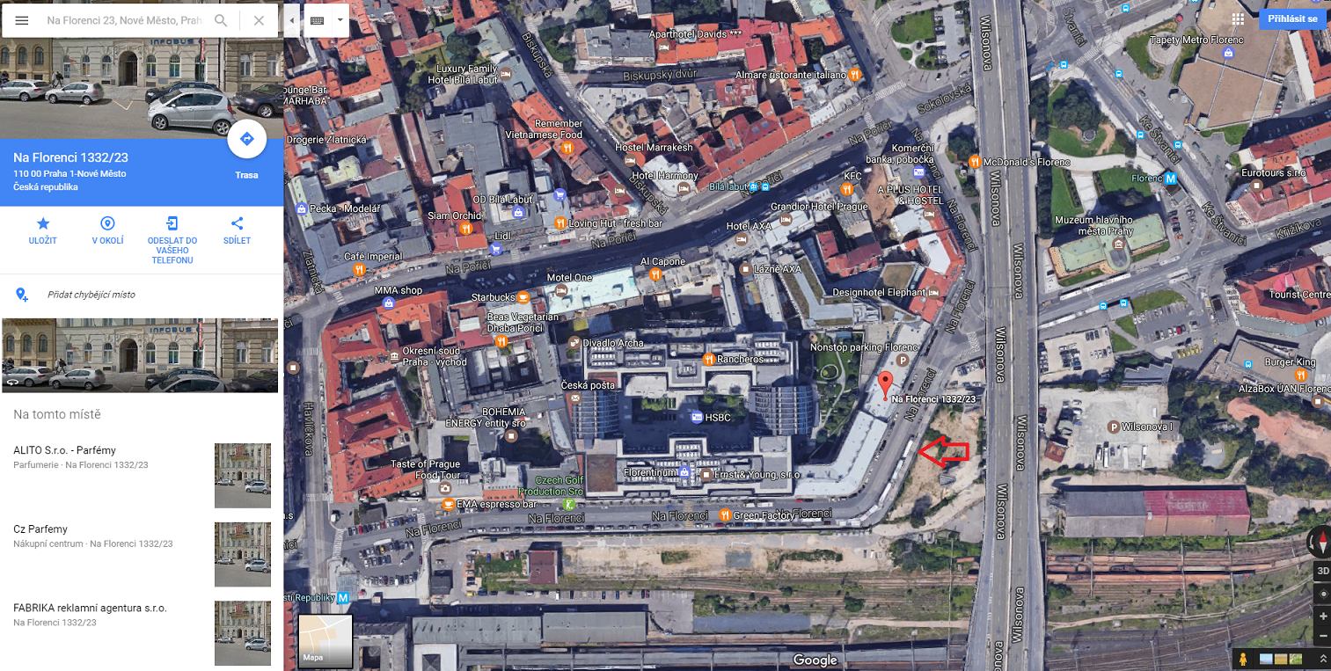Departure point in Prague: Na Florenci Street opposite to number 23.

Schedule:



With kind support of

